CASE - BRAND EQUITY

ADWAIT TORO

STD ID – 89487135

Q1 - What statistical analysis is suitable to measure brand equity with the collected data? Why?

* The statistical measures used to analyze the brand equity based on the survey data are –
  + **Cross tab analysis** – Cross tab illustrates the simple relationship between two discrete/categorical variables. For our survey data, if we divide the age column into age groups or age buckets, then using cross tab we can find the age bin wise effect or sort of a histogram for each question asked to an individual about the brand such as popularity, usability, etc.

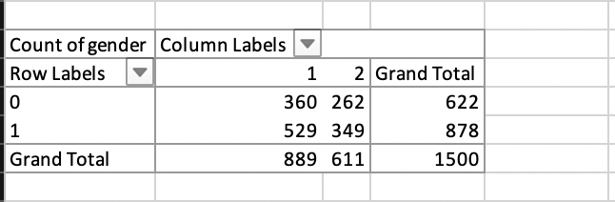

* + For the above image, we can see a cross tab analysis between age and customer’s response to familiarity of the product. It is observed that a greater number of females and males from the total number of females and males are familiar with the product. This way, we can find the gender preference or influence on the brand equity.
  + **Chi-Square test** - The Chi-Square test is a statistical procedure used to examine the differences between categorical variables in the same population.

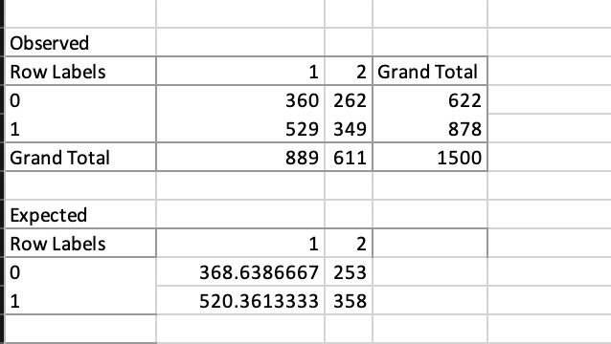

* + Once, we have the observed and expected values, we can find the chi-square value by using the formula –

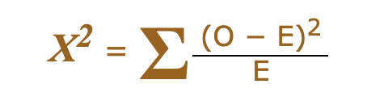

Where O = Observed value and E = Expected Value.

* + Converting the chi-square value to p-value, we can decide whether gender influences familiarity survey response or not. This is another way to measure the dependency of two variables.
  + **Mode** – The most frequent number—that is, the number that occurs the highest number of times.
  + If we calculate the mode for each factor such as famil, uniq, relev, etc. responses, then we can find what most of the customers rate those factors in terms of 0 and 1 where 0 means 1-7(low) and 1 means 8,9,10(high). Thus, for example if familiarity column has a mode of 1, then we can conclude that most of the customers are quite familiar with the brand’s product and thus mode can be a good measure for calculating brand equity.

Q2 - Compare loyalty, relevance, familiarity, uniqueness and popularity for its brands using the appropriate statistical analysis.

* To compare loyalty, relevance, familiarity, uniqueness and popularity across brands, I decided to use the cross tab statistical analysis methodology so that we would be able to see the most popular brand, most liked and most disliked brand by the measures of brand equity.
* Following is the cross tab for the same –
  + For ratings (8,9,10) or high ratings (1) –

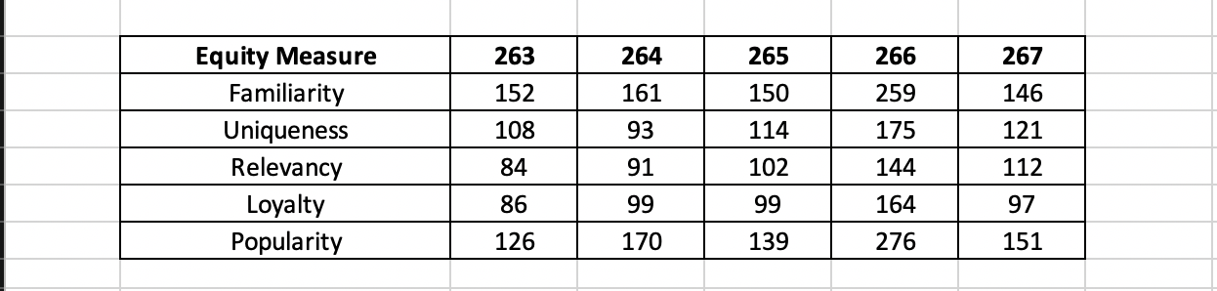

* Looking at the above chart, McDonalds has the highest count of good ratings in which suggests that McDonalds is the most familiar, unique, relevant, loyal and most important due to all of these, it is the most popular brand to the customers as compared to the rest of the brands.
  + For ratings (1-7) or low ratings (0) –

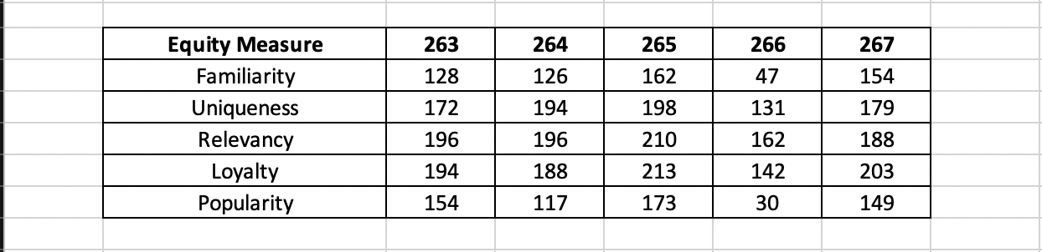

* + Looking at the above chart, Harvey’s has the highest count of low ratings in all of the equity measures which suggests that Harvey’s is the least familiar, unique, relevant, loyal and most important due to all of these, it is the least popular brand to the customers as compared to the rest of the brands.
  + Thus, McDonalds is the best performing brand whereas Harvey’s is the worst performing brand in terms of equity measures.
  + Cross tab results –

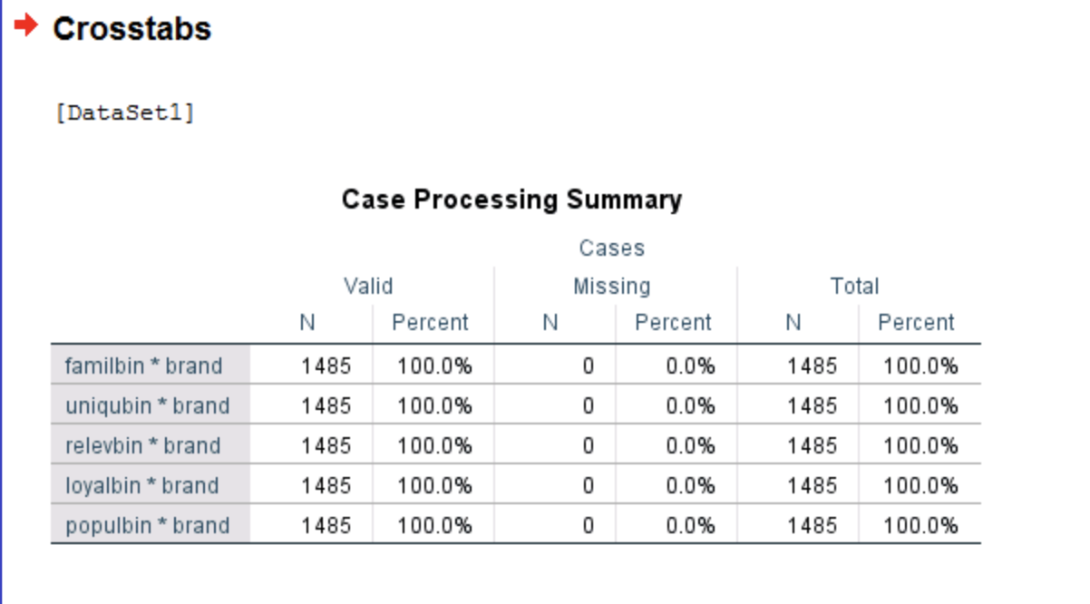

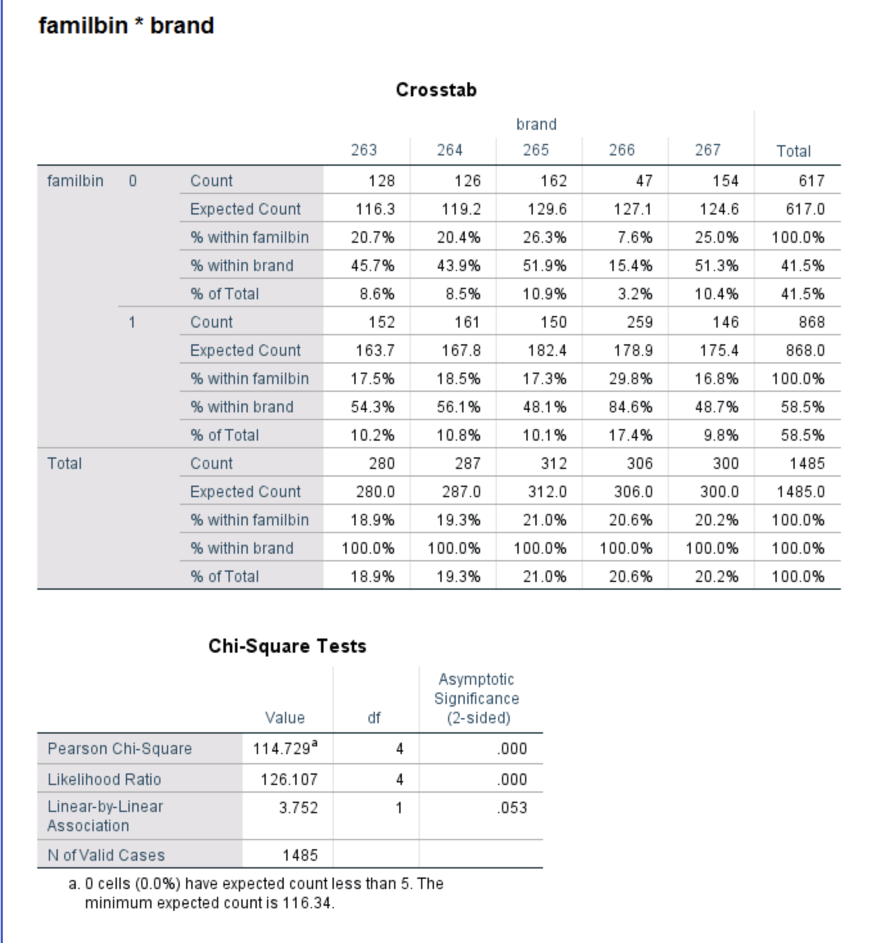

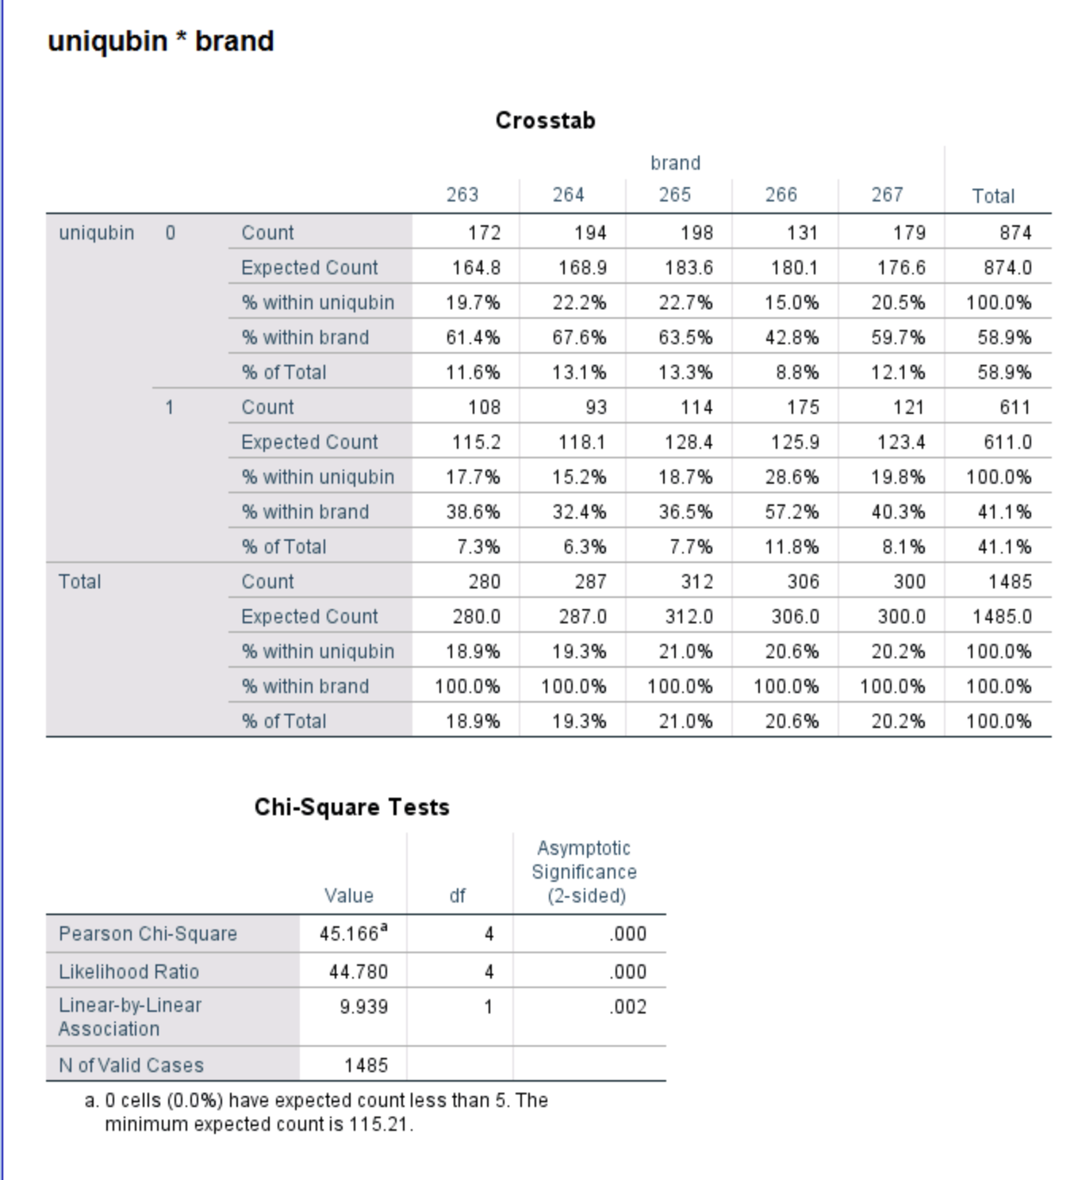

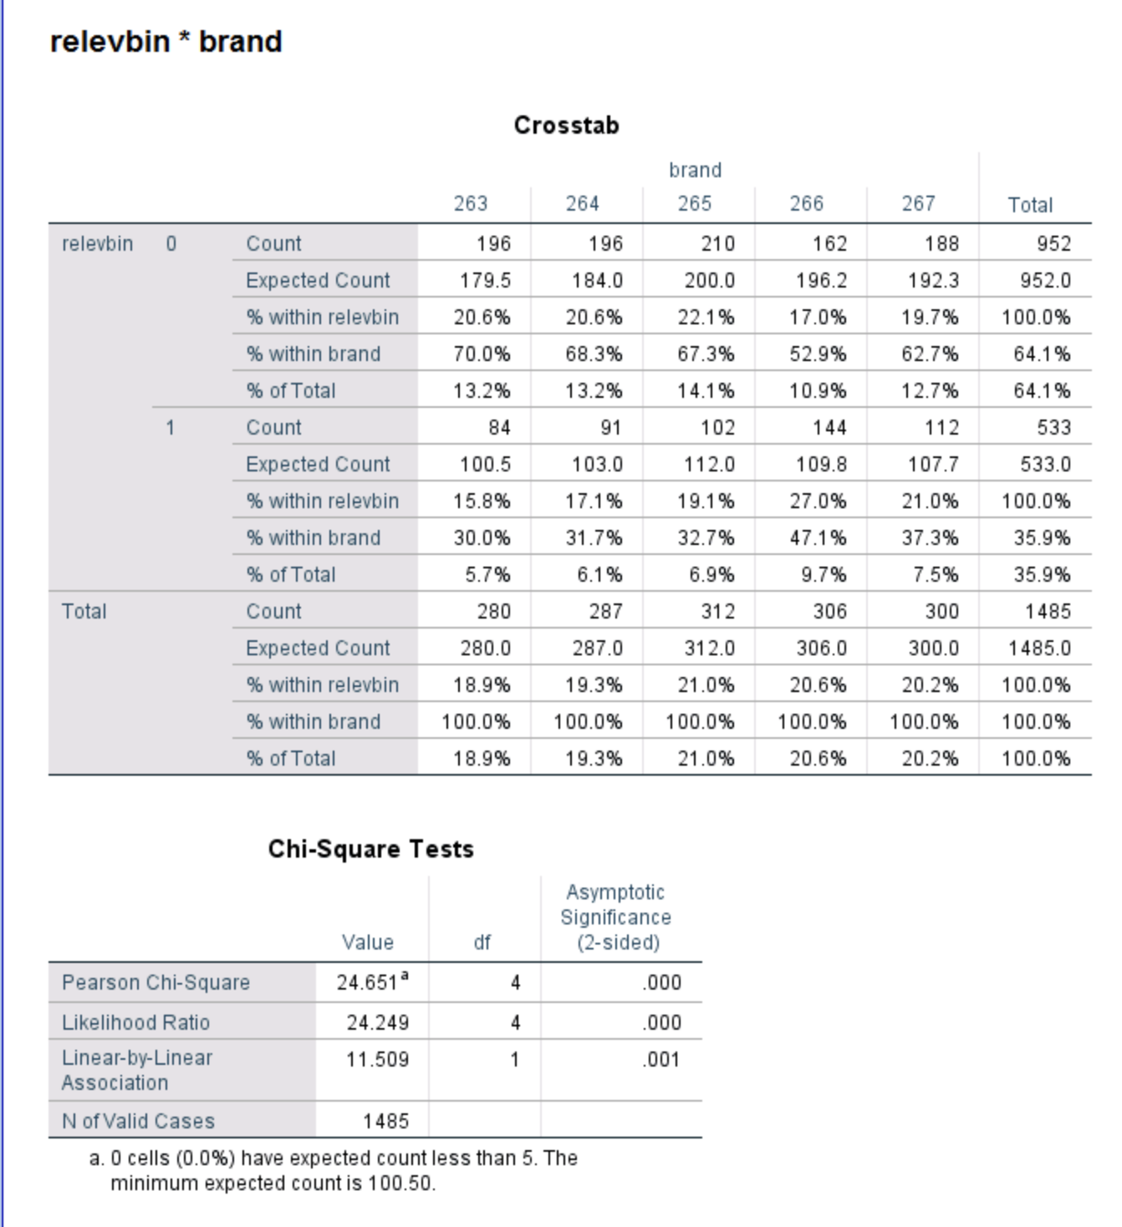

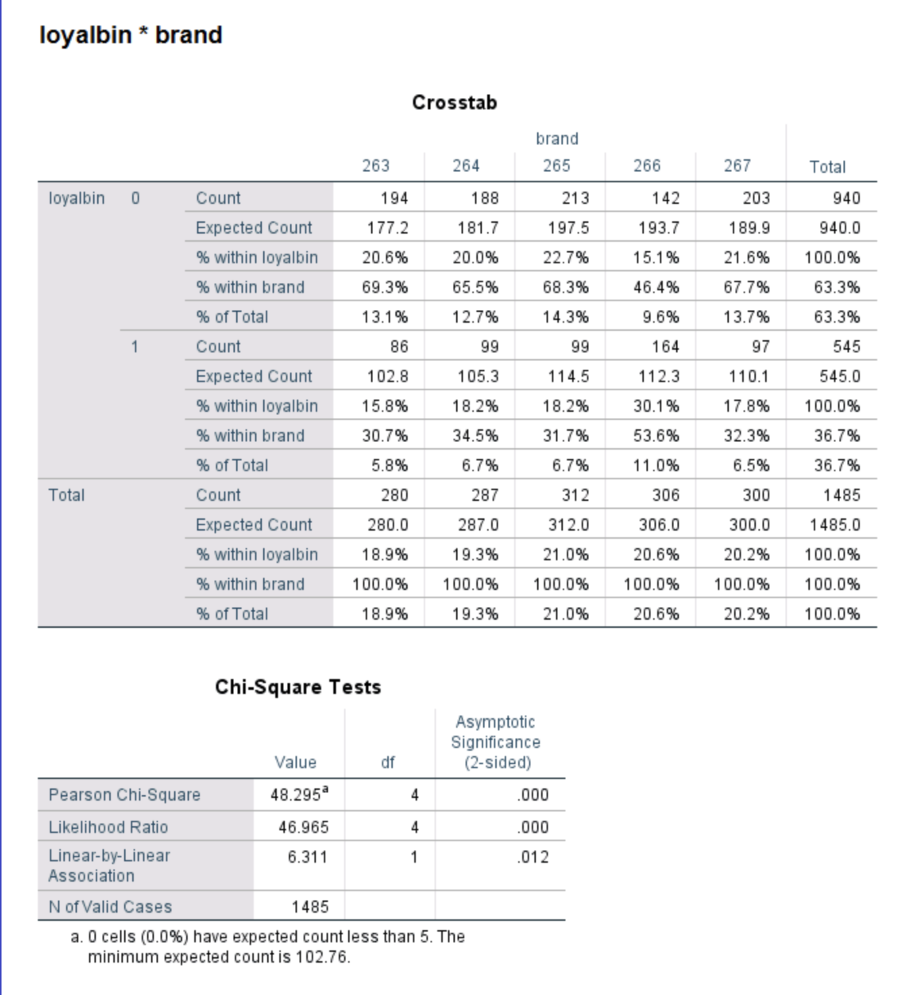

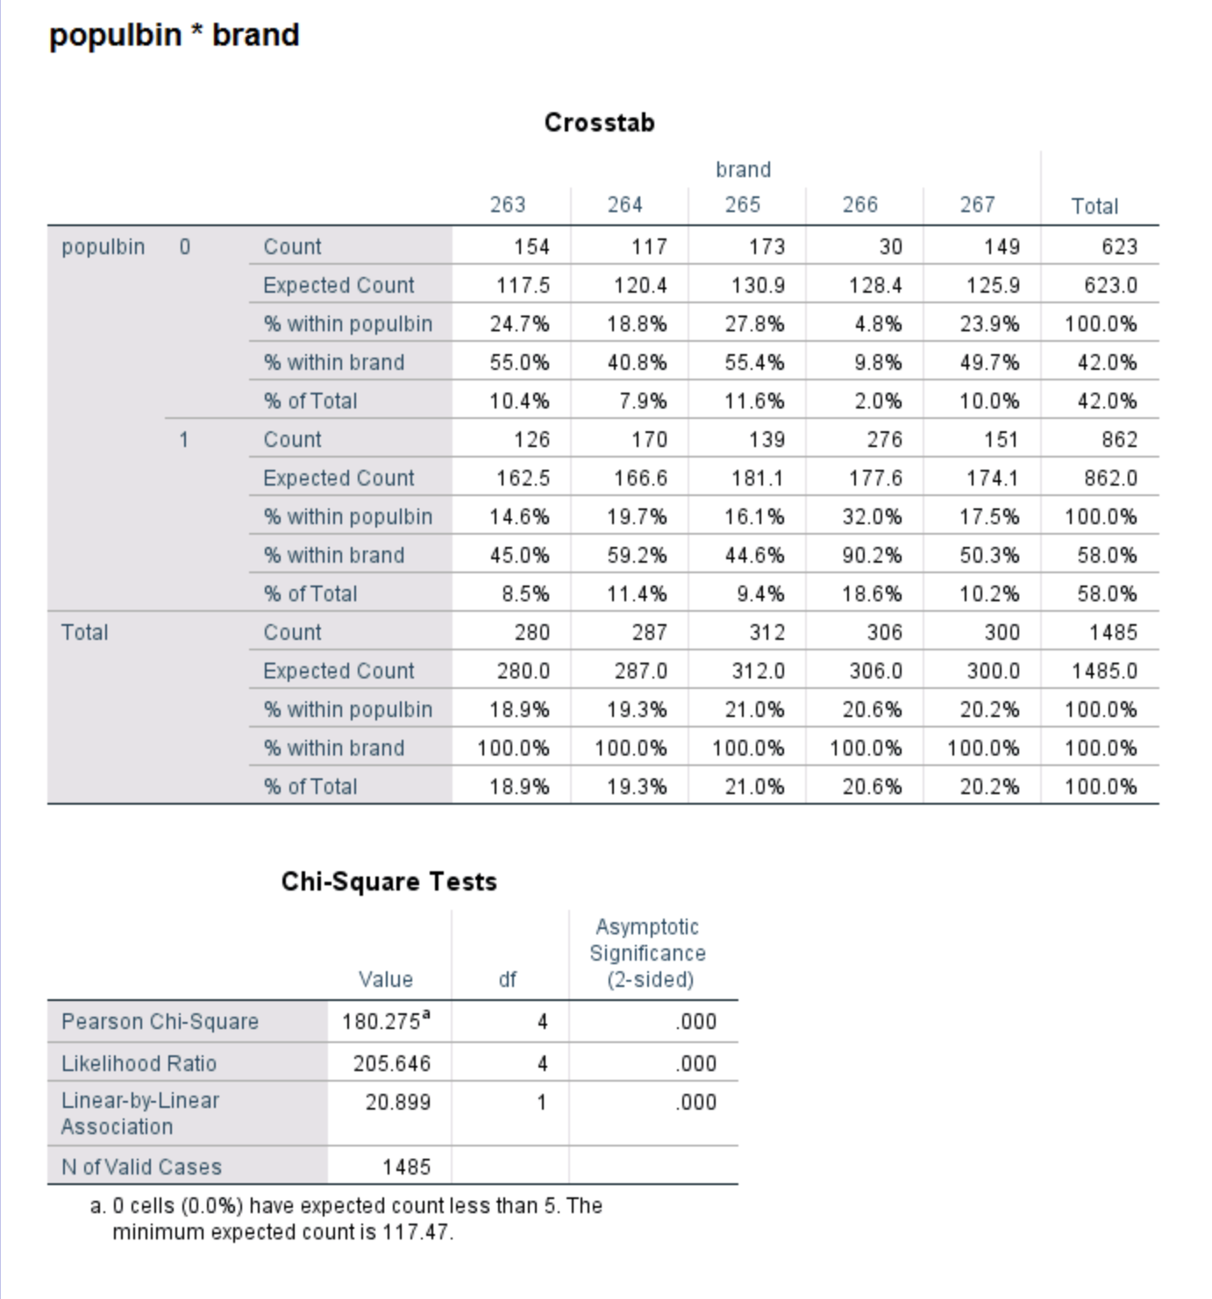

* Looking at the above cross tab results and the respective p-values of the 5 brand equity measures, we find that all the measures are significant to the brands.
* Cross tab for each brand for each rating –

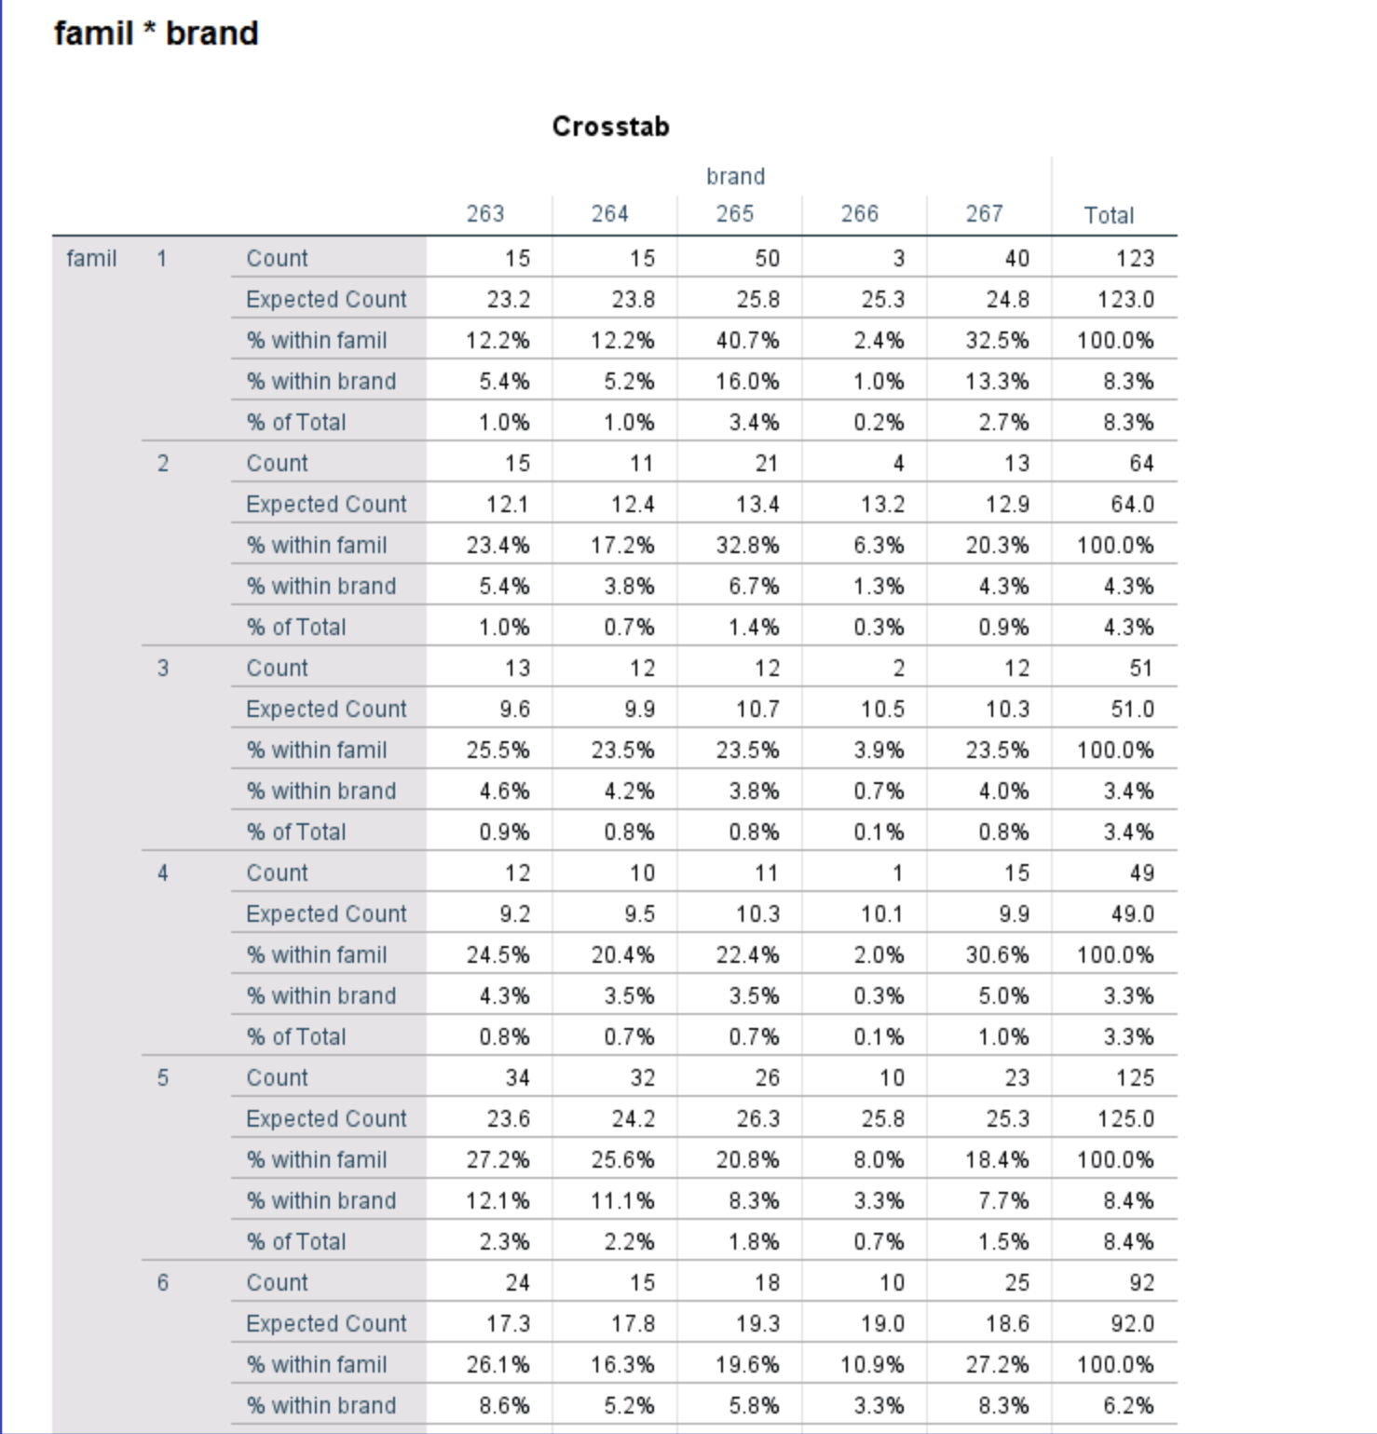

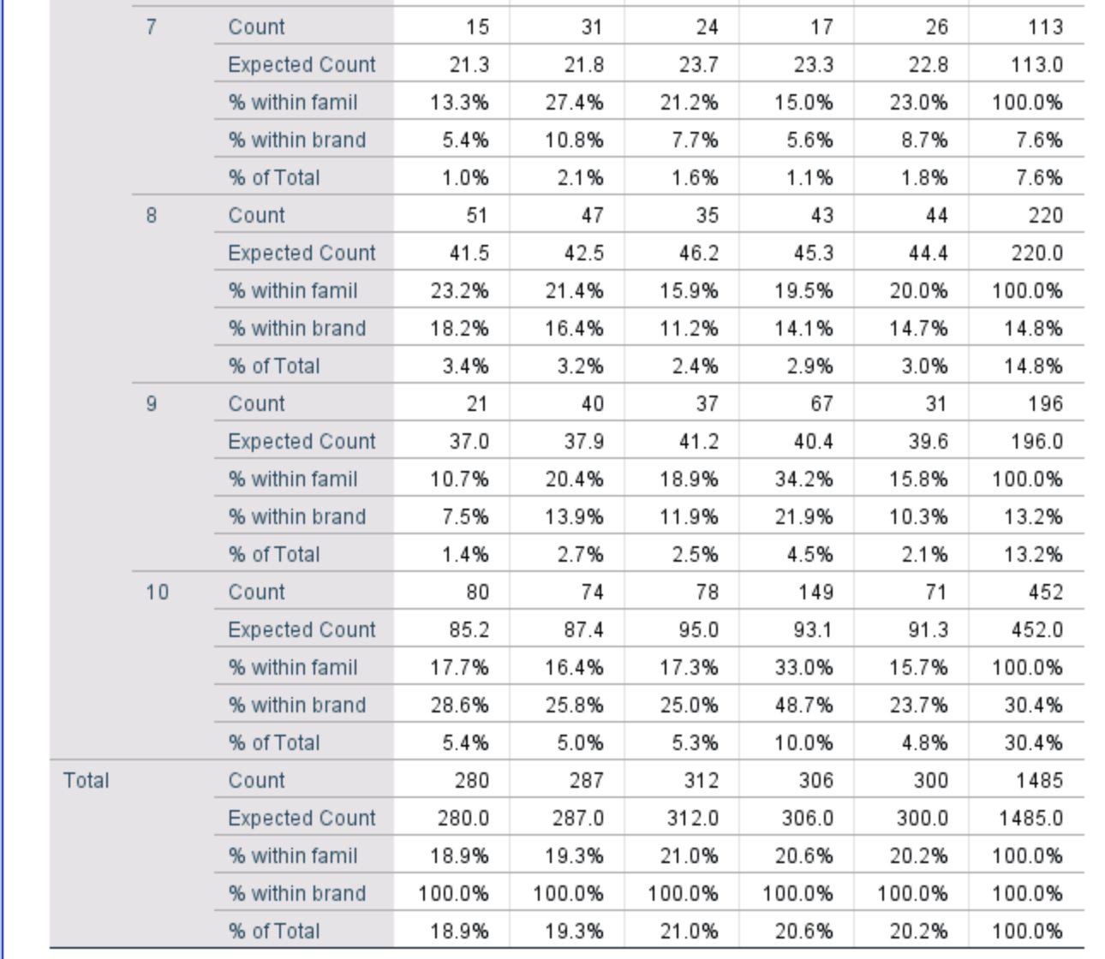

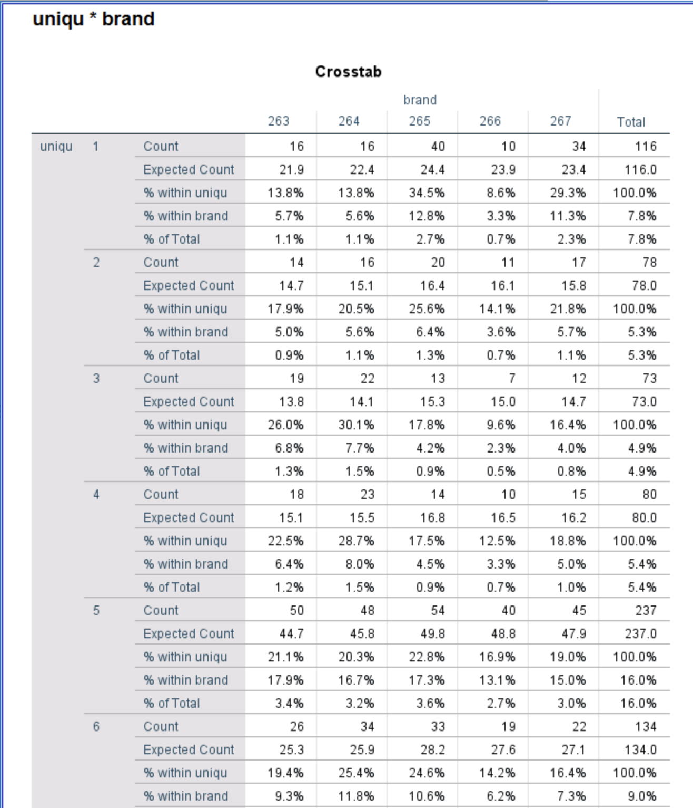

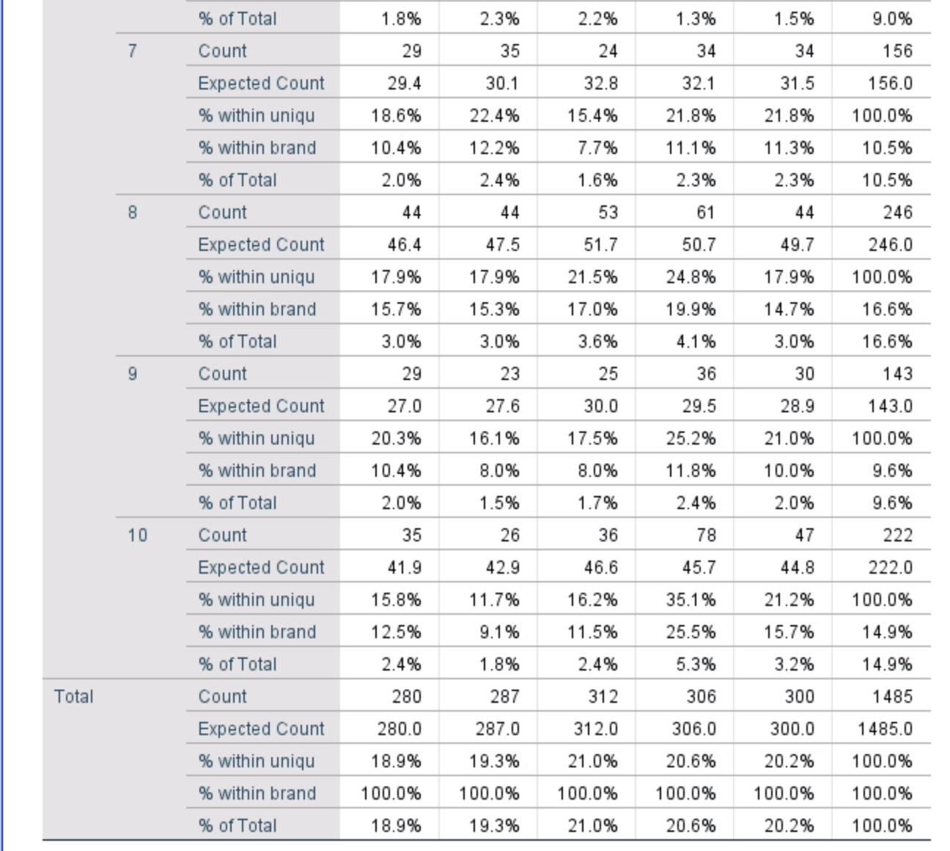

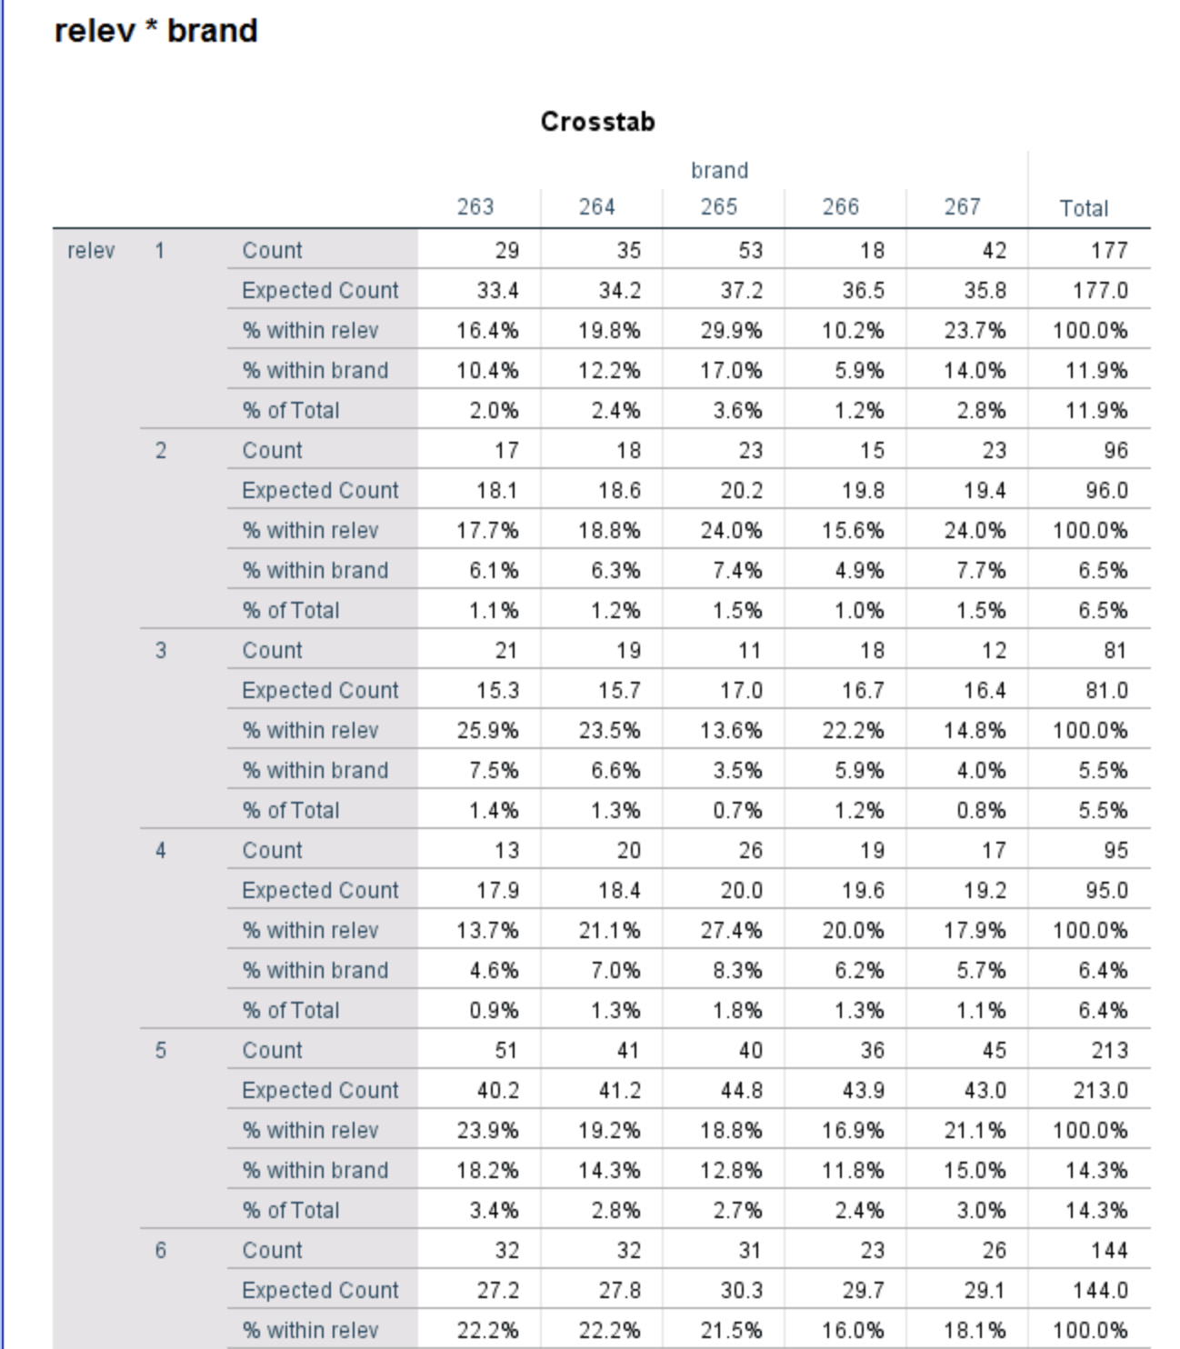

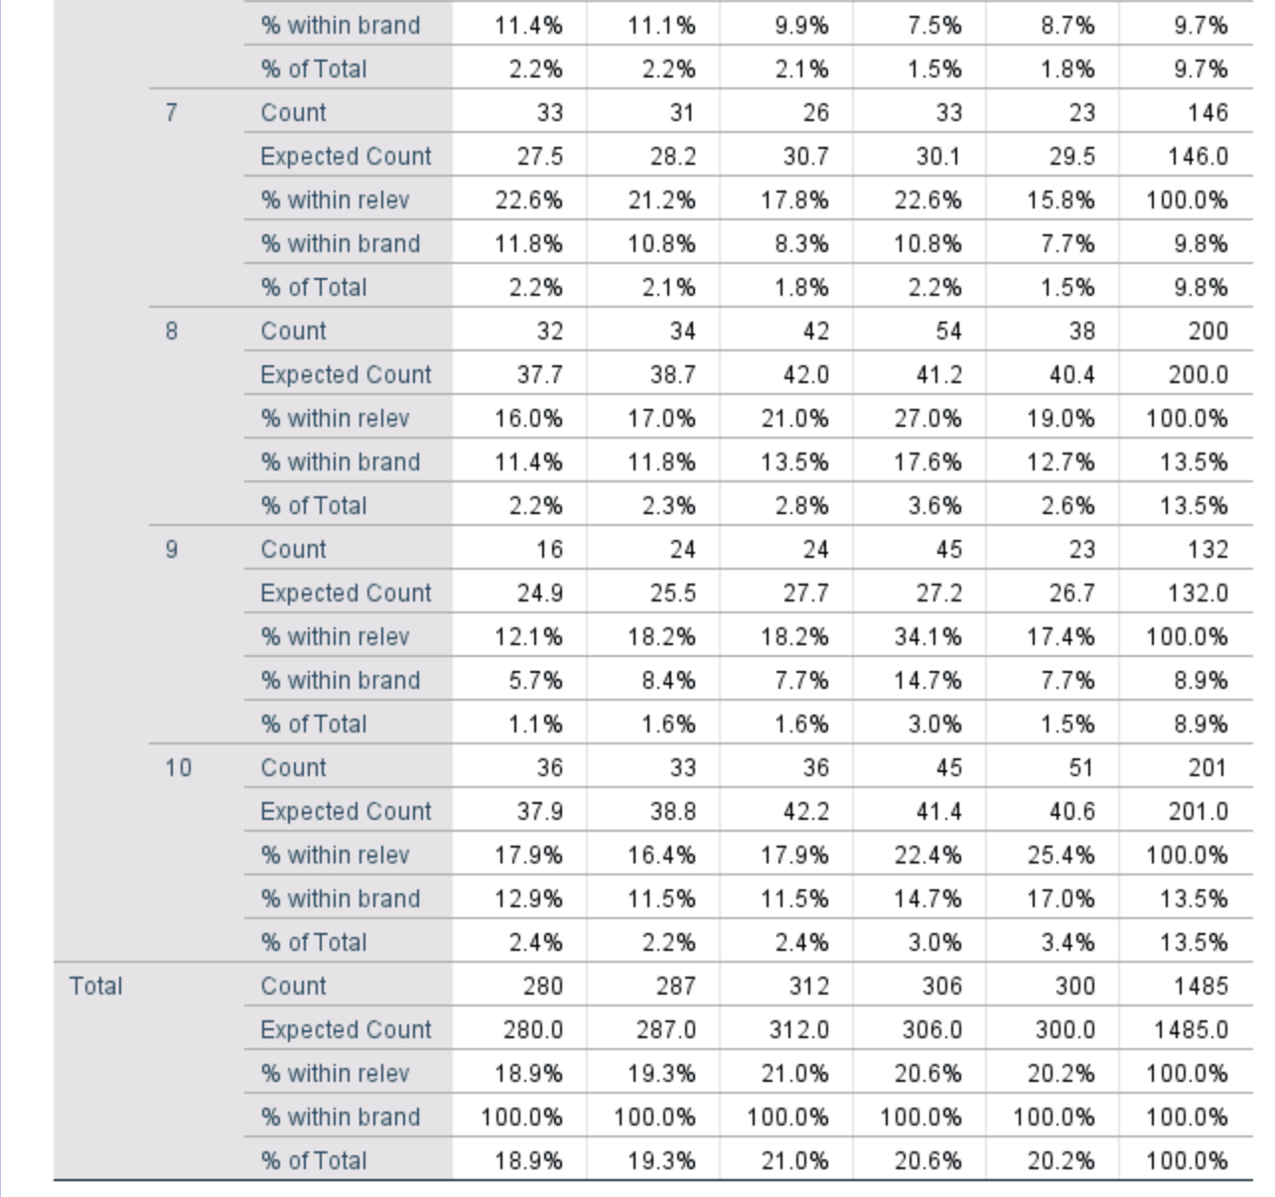

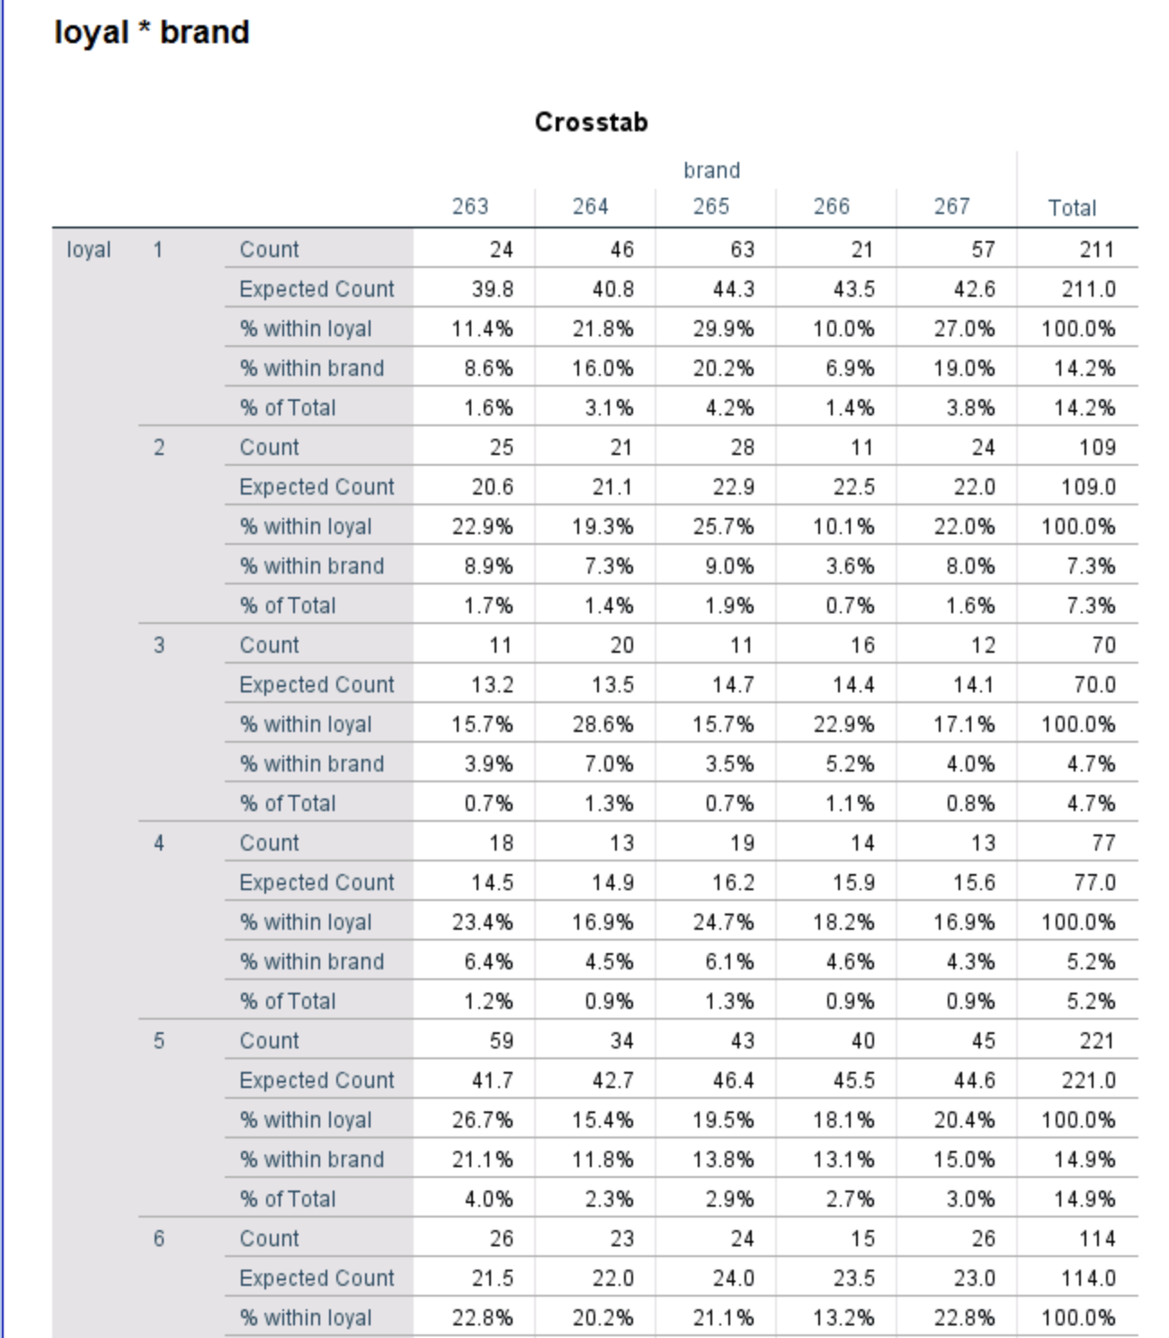

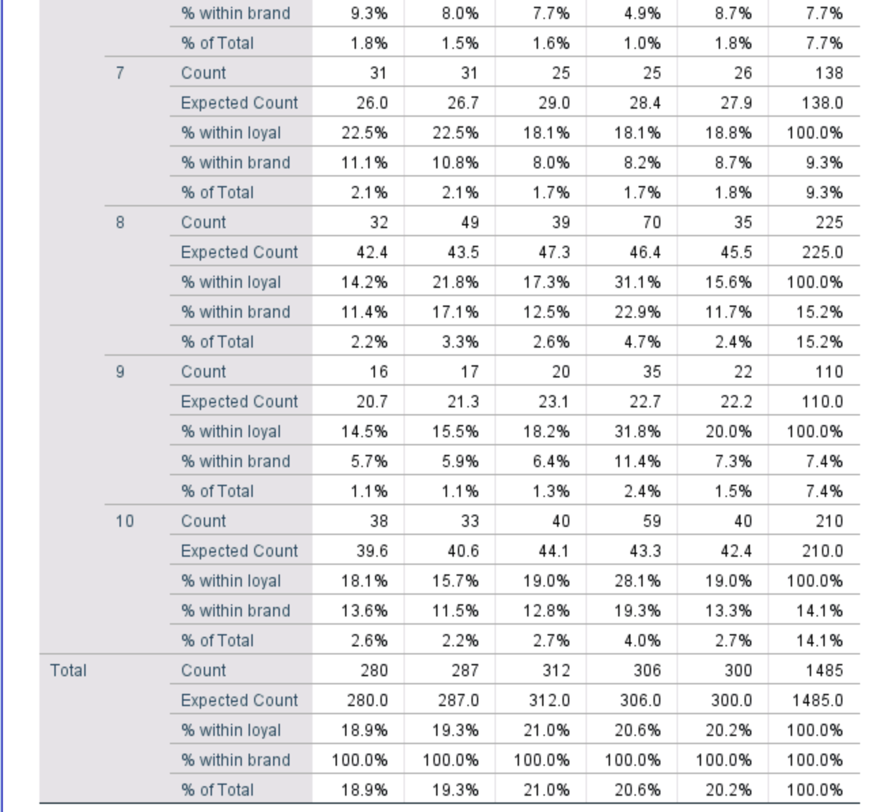

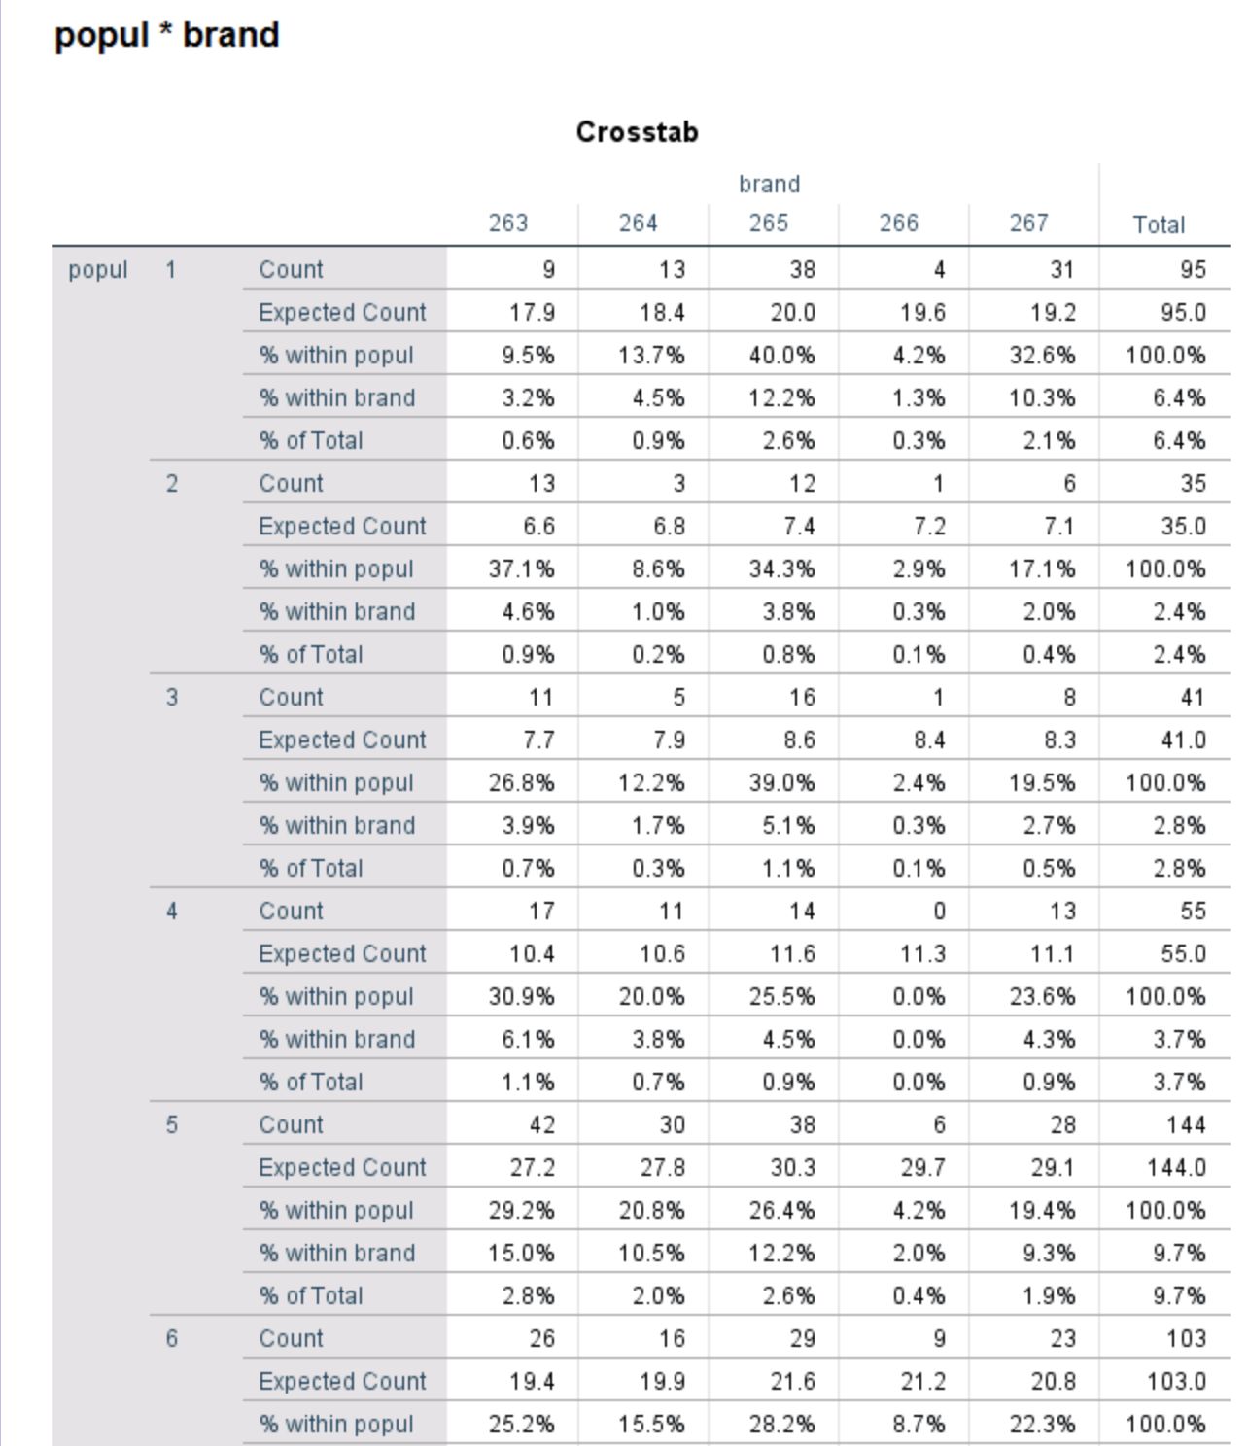

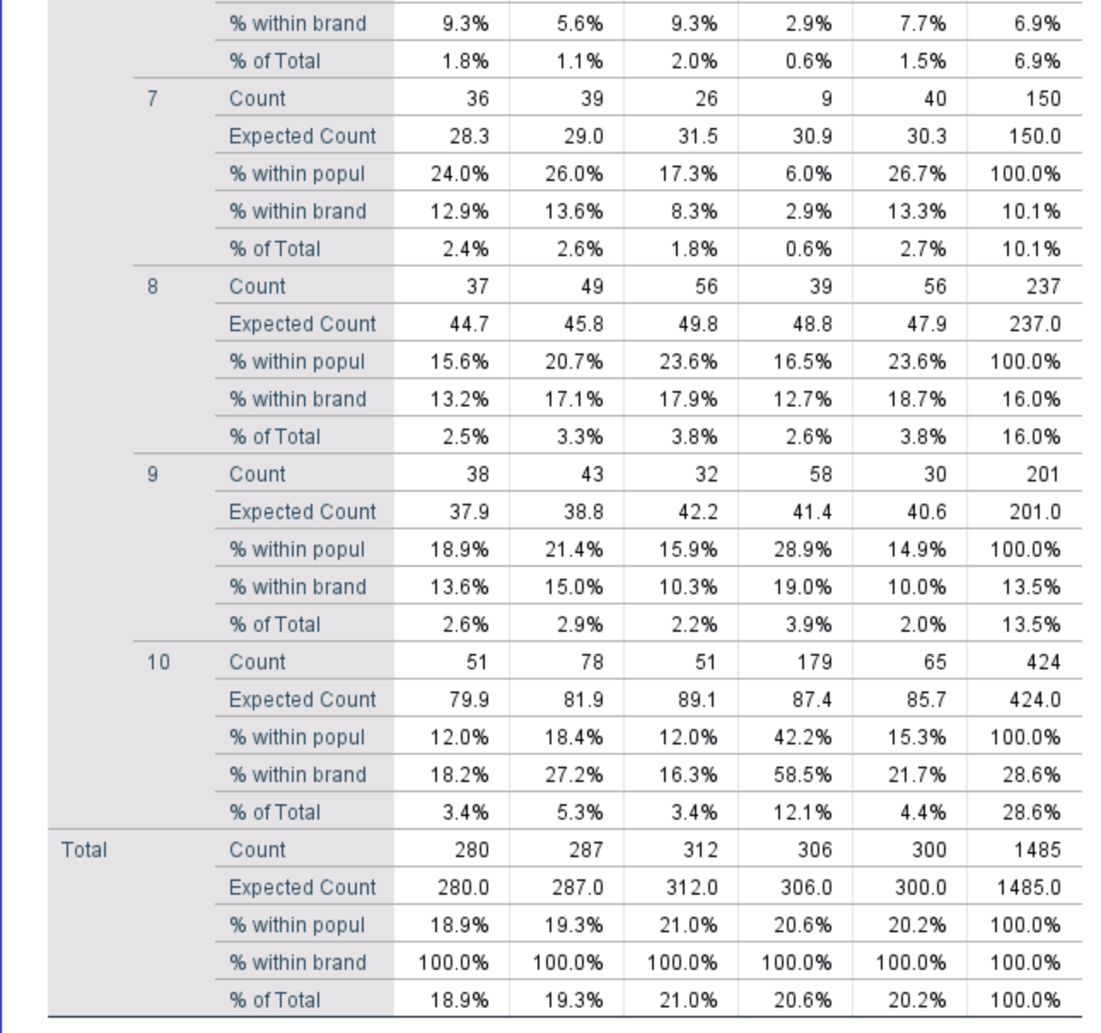

Q3 - Analyse a fast food brand to determine relationships between loyalty and the respondent profiles (e.g., age, region, income).

1. Age -

* Loyalty bin by age –

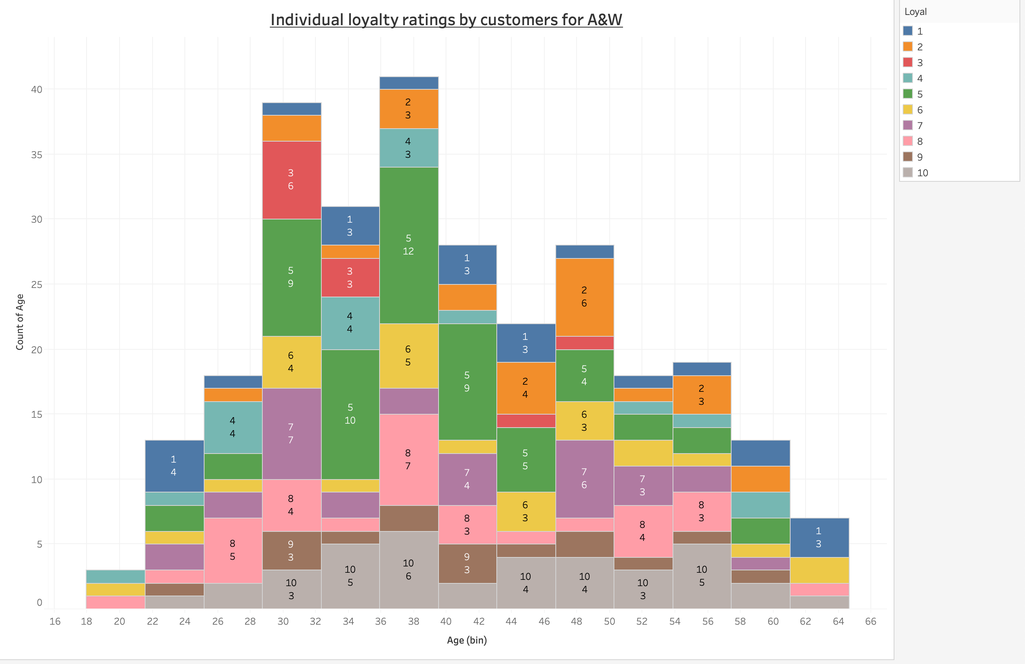

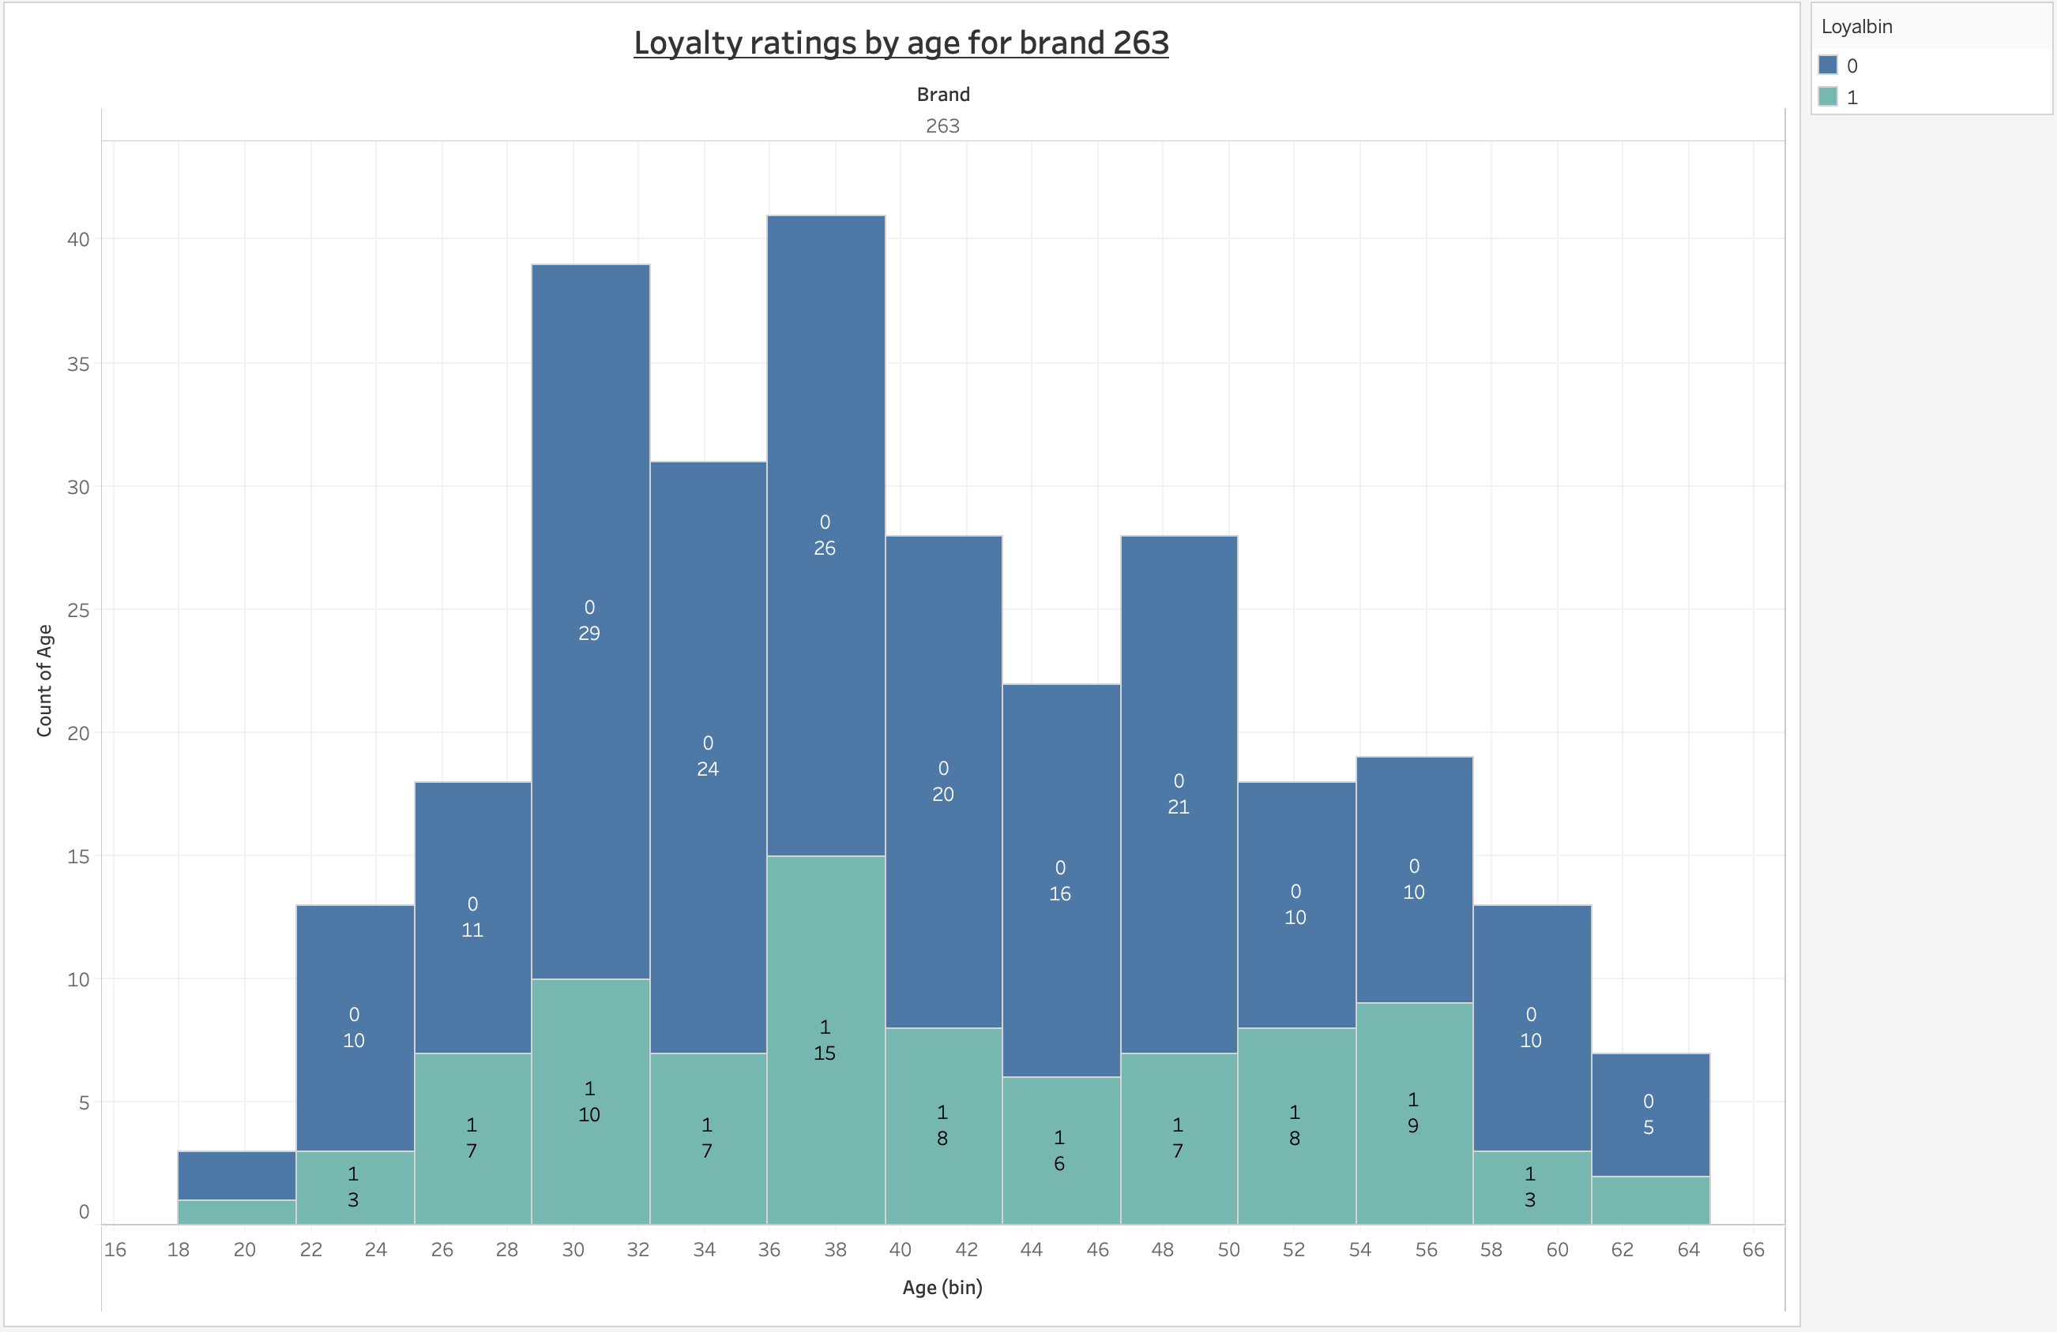

* From the above visualisation we can see that age group 36-40 has the highest number of ratings for loyalty.
* Most of the people from this age group think that A&W is a loyal brand.
* On the contrary, people from age group 28-32 think that A&W doesn’t seem to be a loyal brand to them as they have a high majority of low ratings for A&W in terms of loyalty.

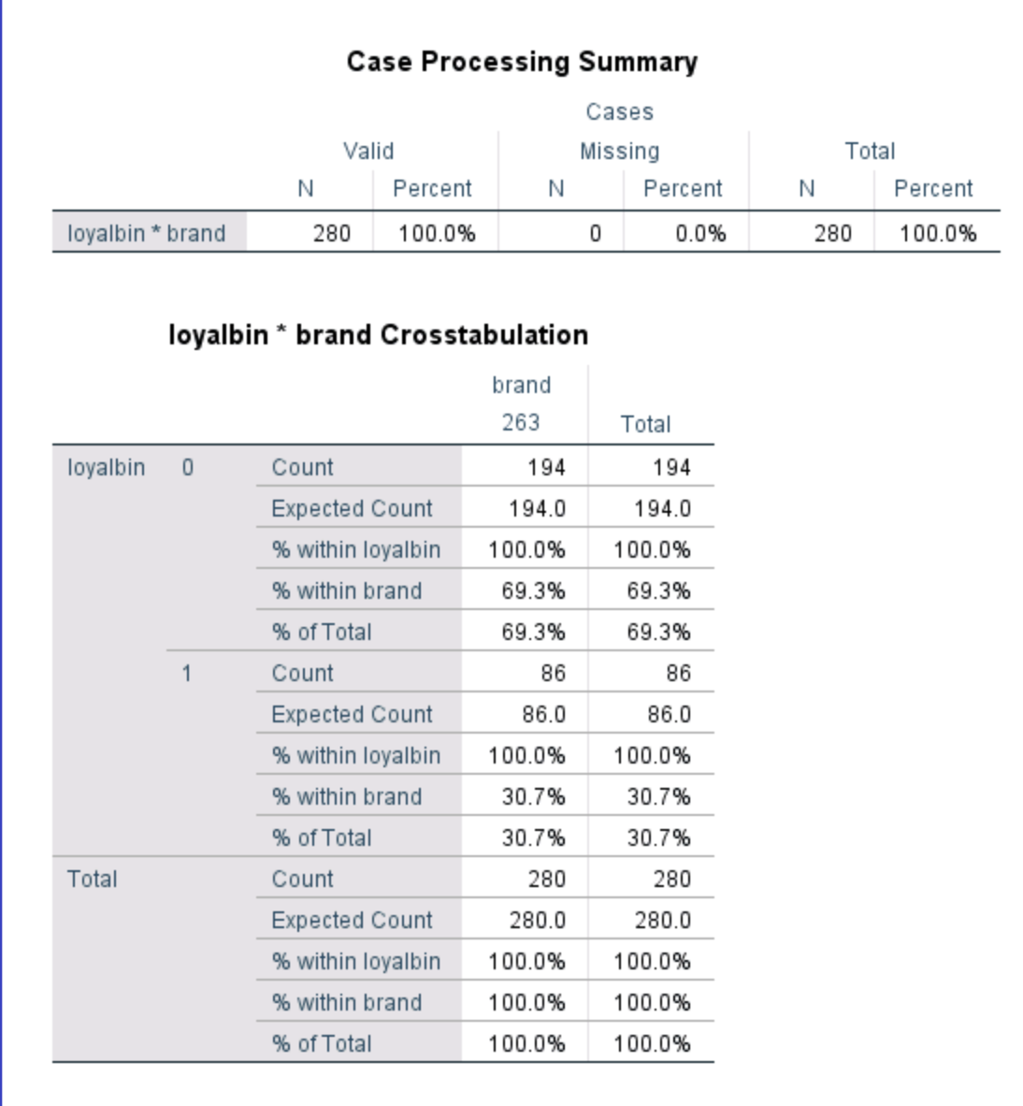

* On looking at the crosstab results, we see that A&W has the highest number of low ratings (0) in terms of loyalty. Thus, people feel that A&W is the most disloyal brand.

1. Region –

* Region wise loyalty rating count –

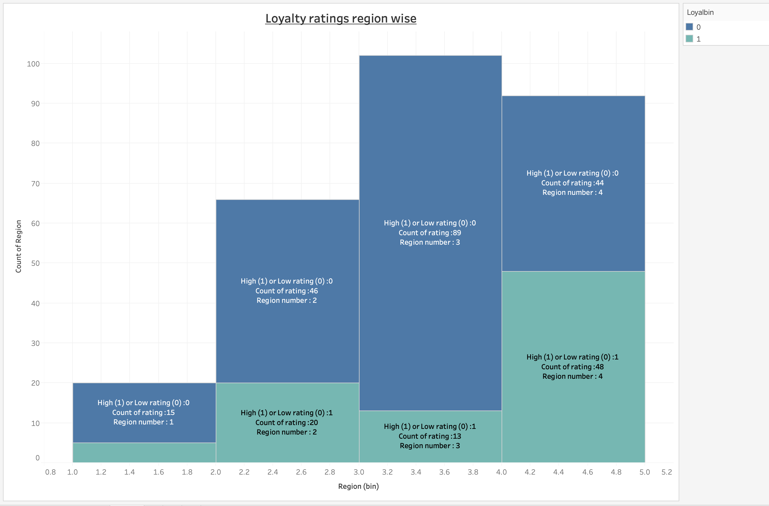

* As per the above graph, we can observe that customers from region West rate and trust A&W for its loyalty.
* On the contrary, customers from Ontario feel that A&W is disloyal to them and hence give a high number of low ratings to A&W.
* Ontario region has a great discrepancy between the count of high ratings and low ratings.
* Crosstab results for region –

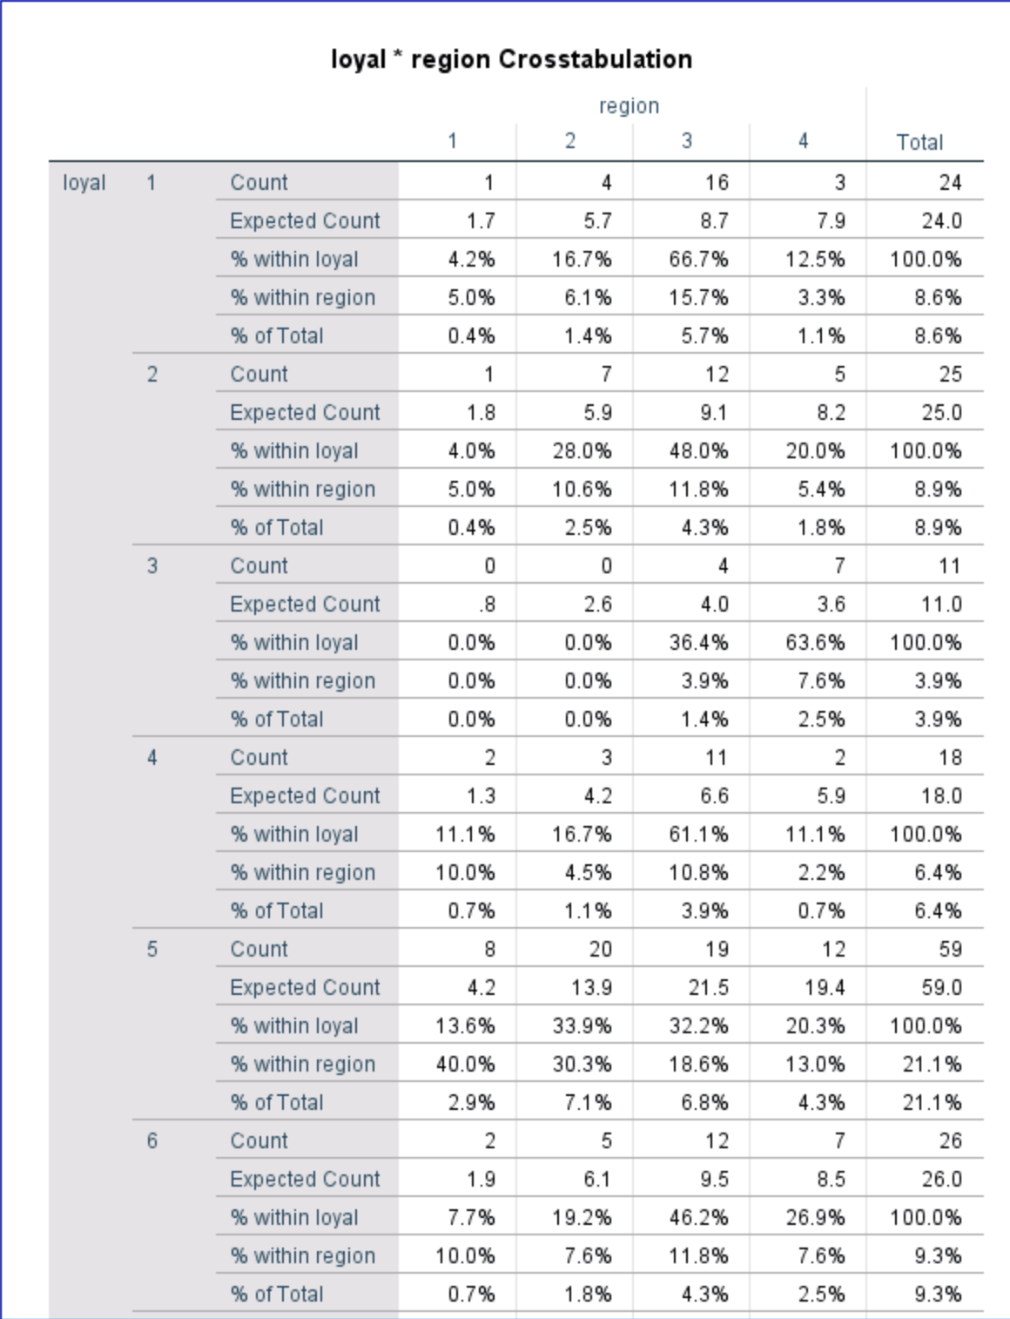

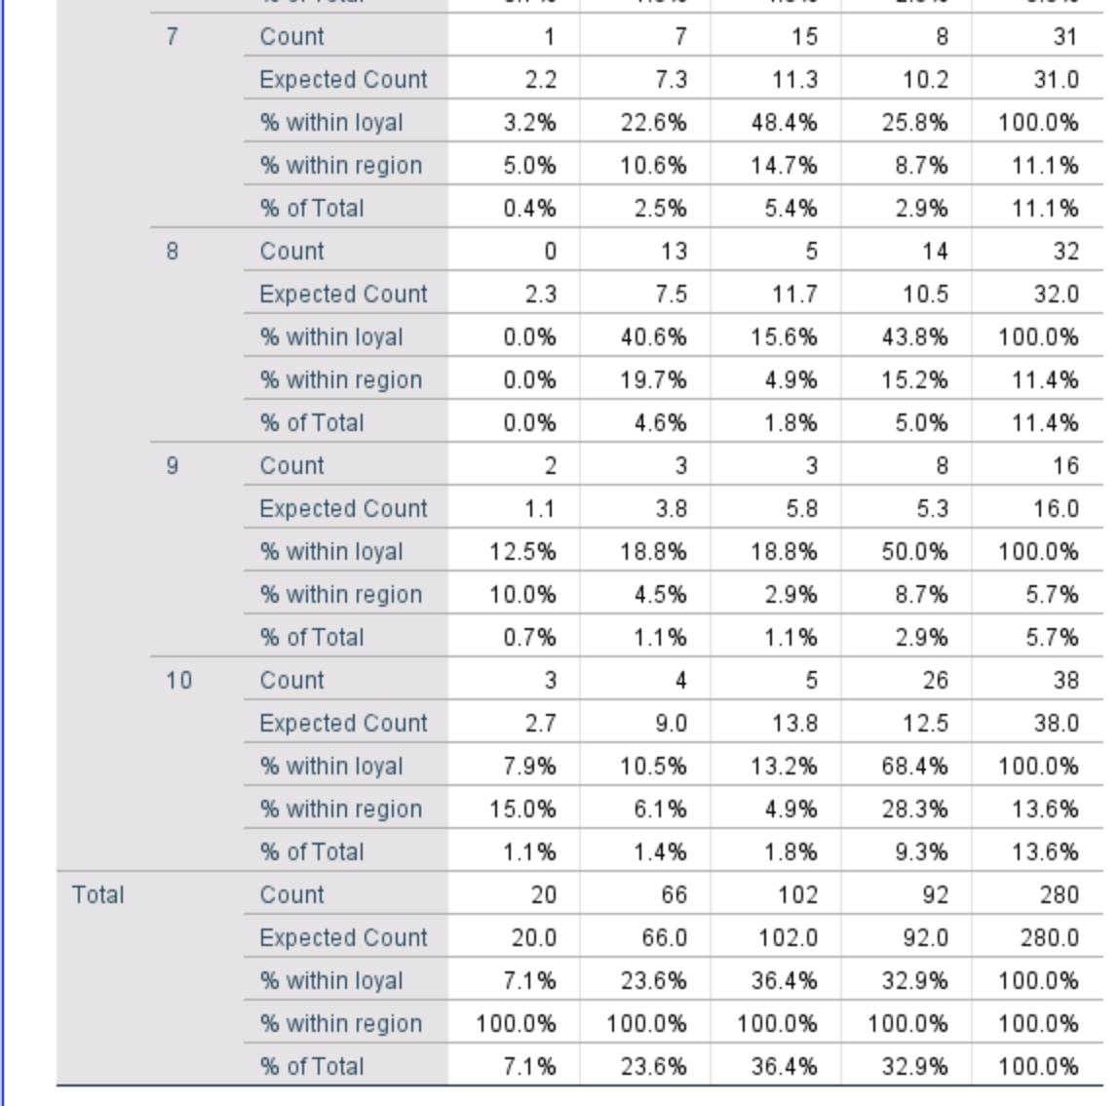

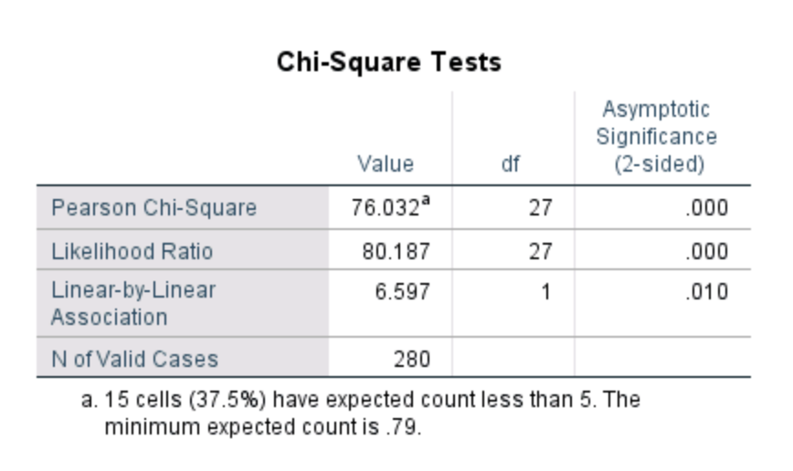

* After doing the chi-square test, it was observed that region and customer loyalty ratings are dependent on each other. Thus, A&W’s loyalty ratings are depended on the geography where the fast food store is located.

1. Income –

* Income wise loyalty ratings –

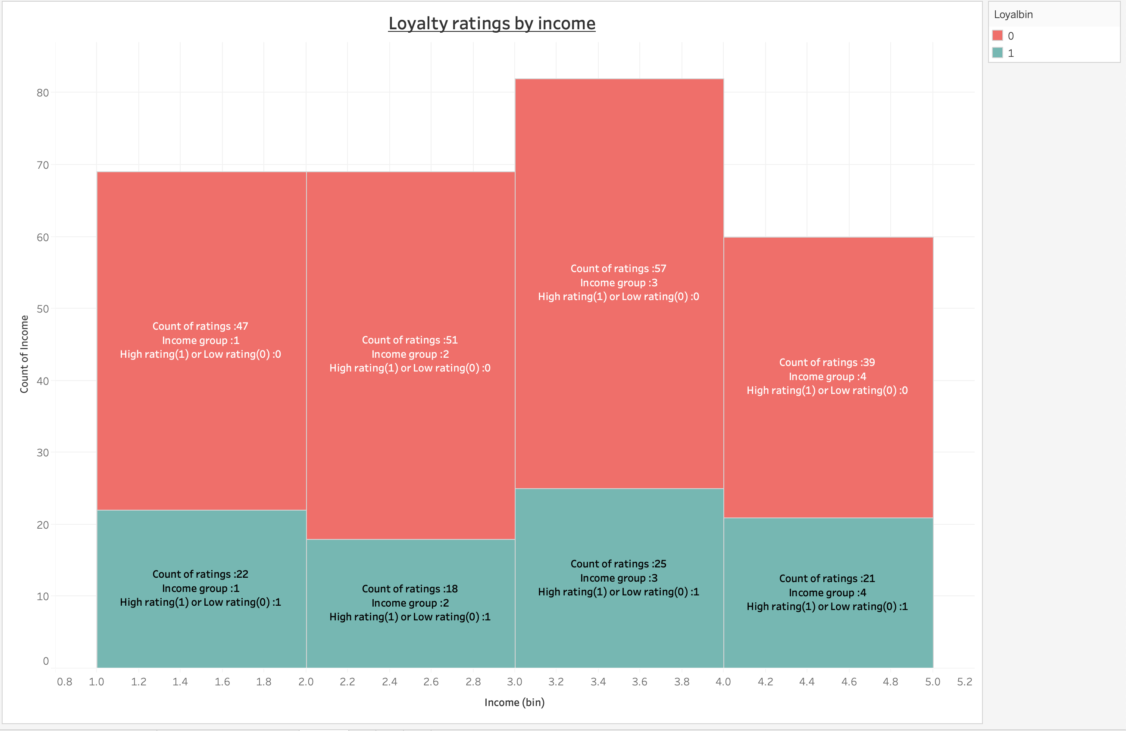

* As far as the loyalty ratings are concerned from the point of view of income, income group 3 i.e. customers with income in the range $50,000 to $75,000 find A&W to be a loyal brand.
* If we see the distribution of low ratings for loyalty, we can observe a similar rating, irrespective of the income group. Thus, given any income group, people feel that A&W brand is not loyal.
* People with income less than $30,000 and in the range of $30,000 and $50,000 show similar behaviours towards the loyalty of A&W.
* Crosstab results and Chi square test –

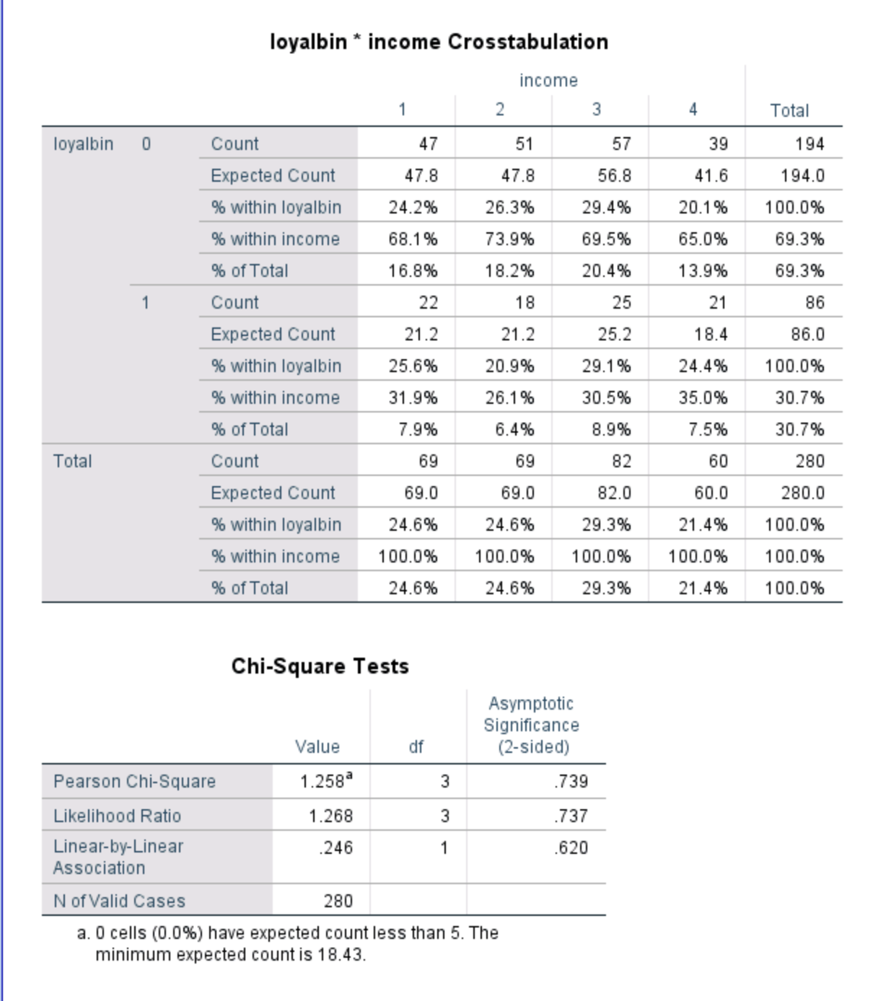

* After doing the chi-square test, it was observed that income group and customer loyalty ratings are dependent on each other. Thus, A&W’s loyalty ratings are depended on the fast food place at which people like to spend money.

Q4 - Ariel created binary variables for familiarity, uniqueness, relevance, loyalty and popularity by splitting responses into “high” and “low.” Why would they choose to do (or not do) this? In other words, what information is gained and what information is lost?

* Customers of Ariel gave their ratings for familiarity, uniqueness, popularity, loyalty and relevancy with respect to Ariel on a scale of 1-10 with 1 being the lowest and 10 being the highest.
* Ariel strategically decided to divide the ratings for each measure into a binary variable column viz 0 and 1 where 0 denoted ratings (1-7) and 1 denoted rating (8,9,10).
* Although this strategy was pretty efficient, it had two major components –
* Information Gained –
* By creating binary variables, it was easier for Ariel to measure the brand equity and analyse the response ratings from its customers as compared to looking at the individual ratings from 1 till 10.
* Through binary variable, Ariel was able to look at only two variables to make business decisions.
* For example, say Ariel wanted to know which regions and which income groups it should target so that a particular customer database which is not finding Ariel to be familiar can be made aware about Ariel.
* In this scenario, if Ariel has 10 different rating variables (1-10), then it becomes difficult to analyse each of them through crosstab or any other statistical analysis as the sample size mentioned in the case is almost made up of 1,25,000 customers.
* Instead, if Ariel has only 2 variables, then it can look at them in two ways statistically viz Mode and crosstab.
* By looking at the mode in a particular column of equity measure, Ariel can determine whether majority of the customers have love towards a particular measure or hatred towards it.
* For example, look at the crosstab analysis for region.

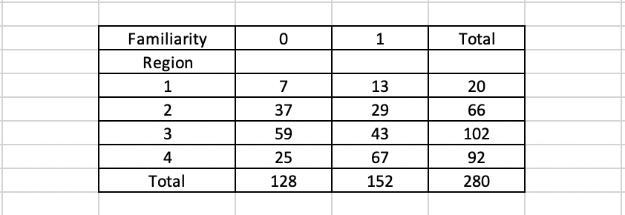

* From the above example, Ariel is quickly able to determine that people from region 3 for a particular brand has high number of low ratings for familiarity that brand. Thus, Ariel can focus on its marketing strategies in region 3.
* Now consider an example where Ariel wants to know out of the 5 equity measures, which one needs more attention.
* Take a look at the mode analysis –

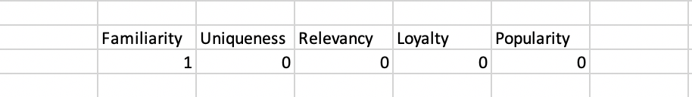

* Thus, we can see that Ariel has a lot of familiarity in its customer base but needs to pay attention to the rest of the measures.
* Information Lost –
* As mentioned earlier, Ariel is replacing low ratings by 0 and high ratings by 1.
* The problem with this is that by doing so, Ariel is accounting for a significant loss of information.
* Say customer A rates familiarity as 1 and customer B rates familiarity as 7.
* In this case, as per the binary strategy, it is assumed that both customers A and B rate familiarity as 0 which is pretty low.
* Whereas a rating of 8 would be considered as 1 which is a high rating.
* Thus, in doing so, ratings of 1 and 7 are considered to be on the same scale and marked as 0 which leads to discrepancy in the ratings.
* Also, a rating of 7 doesn’t necessarily mean a complete dislike or negligence towards that particular equity measure.

Q5 - Do you agree with Ariel’s measure of brand equity?

* According to me, in this modern world, brands not only need to produce products that satisfy the needs of the customer but also, they need to take feedbacks from the customers to ensure the product is moving in the right direction.
* Thus, following this thumb of rule, Ariel has properly devised a survey questionnaire with 5 simple measures which are to be rated by the customers.
* As far as the survey strategy goes, Ariel has done a good job in capturing the responses of the customers.
* But as far as measuring the brand equity is concerned, I partially agree with Ariel’s strategy of converting the rating responses to binary variables of 0 and 1.
* The main advantage of this approach is to quickly get a sense of how each measure is performing with respect to various demographics such as age, income, gender, geography, etc.
* Taking the mode of these ratings makes it easier to analyse the current situation of the customers w.r.t Ariel.
* But on the other hand, there is a huge gap in interpretations.
* Rating of 1 and 7 are interpreted to be the same even though a rating of 1 is very bad and a rating of 7 is somewhat decent.
* Thus, according to me, Ariel should divide the ratings as -1, 0, 1 or bad, neutral and good.
* This way it will have a sense of the sentiments among its customers.
* A rating range from 1-3 can be denoted as -1 or bad, range from 4-7 can be denoted as 0 or neutral and a range from 8-10 can be denoted as 1 or good rating.
* This will still be easier to model into a crosstab analysis and interpret the results.
* Also, this will allow Ariel to plot different strategies to target customers with bad ratings or -1 and neutral ratings or 0.